Q1: Explain the difference between frontend, backend, and full-stack development with suitable real-world examples.
Ans: Frontend Development:- Frontend Development is the part of the website that works on the user interface and user can directly see and interact with it. It includes the design, layout, buttons, images e.t.c. Users mainly use HTML, CSS and JavaScript.
Real World Example: When we open a website the image, search bar and navigation menu are all part or frontend development.
Backend Development:- Backend Development is the part that works behind the scenes. It handles the business logic, stores and retrieve the data from database, manages user authentications, process requests from frontend. Common backend technologies include JAVA, Python, PHP, Node.js and database like MongoDB or MySQL.
Real World Example:- when we are login a website or place an order, the backend verifies the login details, check product availability, store the order in the database and process the payment.
Full-stack Development:- A full-stack developer can work on the frontend and backend of a website. They have knowledge of designing the user interface as well as managing the server, database and application logic.
Real World Example:- A full-stack developer can build a complete website by creating product pages(frontend) developing the login and payment system(backend) and connecting everything together.
Q2: Create a simple diagram showing how the client-server model works in web architecture.
ANS:- Client-Server Model in Web Architecture

+------------------+ HTTP Request +-----------------------+
| Client | -----------------------------> | Server |
| (Web Browser) | | (Web Application) |
| Chrome, Edge | <----------------------------- | Database & Logic |
+-------------------+ HTTP Response +-----------------------+

Q3:- Describe how a browser requests and displays a web page from a web server.
ANS:- 1. The user enters a website URL in the browser.
2. The browser sends an HTTP request to the web server.
3. The server processes the request and fetches data from the database if needed.
4. The server sends an HTTP response containing the webpage files.
5. The browser renders the HTML, CSS, and JavaScript and displays the webpage.

Q4:- Identify and list the tools required to set up a web development environment. Explain the purpose of each.
ANS:- 1. VS Code – Code Edit
2. Web Browser – Test webpage
3. Node.js – JavaScript runtime
4. Git – Version control
5. Live Server Extension – Live preview
6. Chrome DevTools – Debugging

Q5:- Explain what a web server is and give examples of commonly used servers.
ANS:- A web server is a software or computer that receives requests from a web browser and delivers the requested web pages to the user. It uses HTTP/HTTPS protocols for communication.
Examples: Apache, Nginx, Microsoft IIS, LiteSpeed, Node.js.

Q6:- Define the roles of a frontend developer, backend developer, and database administrator
in a project.
ANS:- 1. Frontend Developer: A frontend developer designs and develops the user interface (UI) of a website. They use HTML, CSS, and JavaScript to create web pages that users can see and interact with.
2. Backend Developer: A backend developer develops the server-side logic of a website. They handle user requests, business logic, and communication with the database using languages like Java, Python, PHP, or Node.js.
3. Database Administrator (DBA): A database administrator manages and maintains the database. They store, organize, secure, and back up data to ensure it is available and protected.

Q7:- Install VS Code and configure it for HTML, CSS, and JavaScript development. Take a
screenshot of the setup.
ANS:- 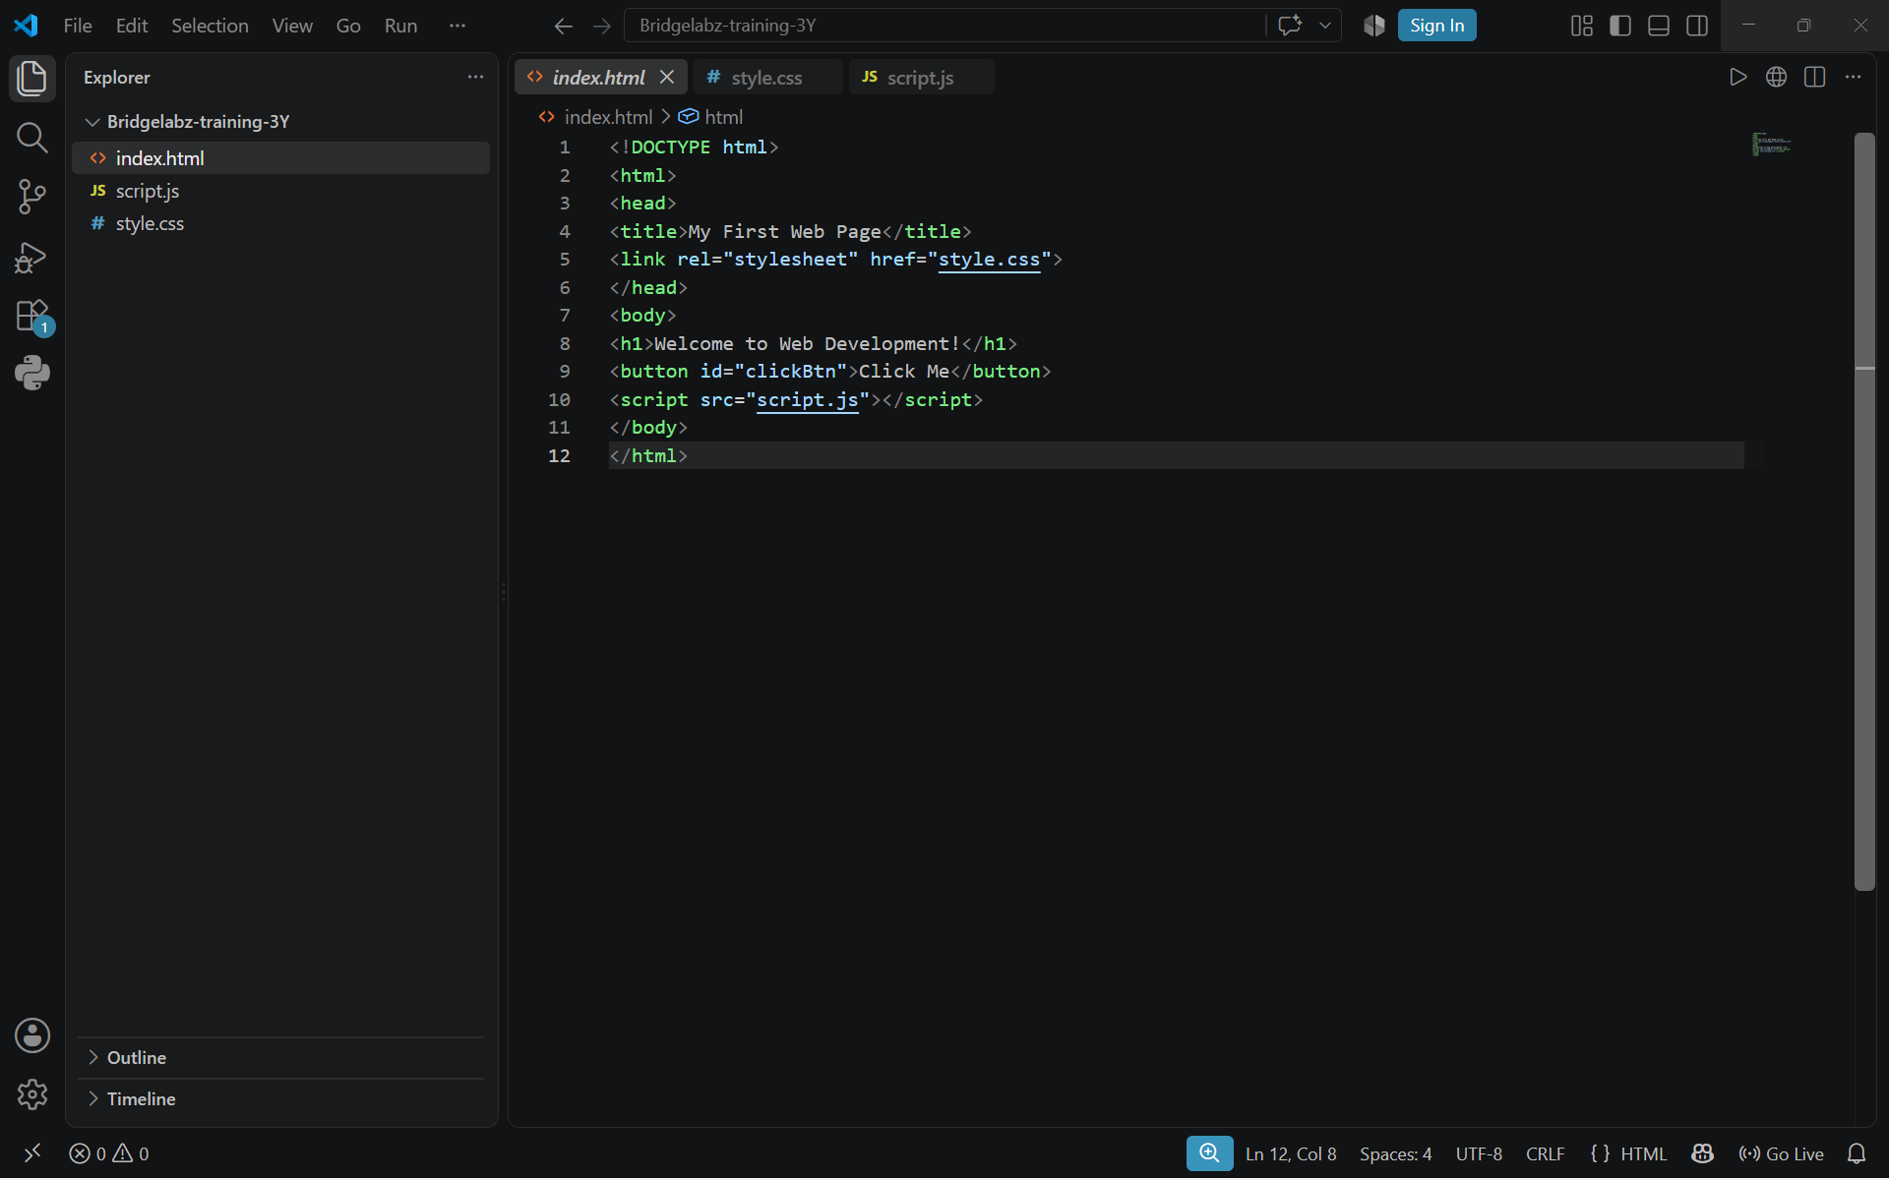

Q8:- Explain the difference between static and dynamic websites. Provide an example of
each.
ANS:- Static Website: A static website displays the same content to every user. The content does not change unless the developer manually updates the website. It is mainly created using HTML and CSS.
Example: A college information website or a personal portfolio website.
Dynamic Website: A dynamic website displays different content based on the user's request or data stored in the database. It is developed using HTML, CSS, JavaScript, and backend technologies like PHP, Python, Java, or Node.js.
Example: Amazon, Facebook, Instagram, and Gmail.
Q9:- Research and list five web browsers. Explain how rendering engines differ between
them.
ANS:-
Web Browser | Rendering Engine
Google Chrome | Blink
Microsoft Edge | Blink
Mozilla Firefox | Gecko
Apple Safari | WebKit
Opera | Blink

Q10:- Draw a labeled diagram showing the basic web architecture flow — client, server,
database, and APIs.
ANS:- WEB ARCHITECTURE FLOW

┌──────────────────────┐
│ CLIENT │
│──────────────────────│
│ • Web Browser │
│ • Mobile App │
│ • Desktop │
└──────────────────────┘
│
│ HTTP Request
▼
┌──────────────────────┐
│ WEB SERVER │
│──────────────────────│
│ • Processes Request │
│ • Business Logic │
└──────────────────────┘
│ │
│ │ API Call
│ ▼
│ ┌──────────────────┐
│ │ APIs │
│ │───────────────── │
│ │ Payment API │
│ │ Maps API │
│ │ Weather API │
│ └──────────────────┘
│
│ Database Query
▼
┌──────────────────────┐
│ DATABASE │
│──────────────────────│
│ Users │
│ Products │
│ Orders │
└──────────────────────┘
▲
│ Data Returned
│
┌──────────────────────┐
│ WEB SERVER │
└──────────────────────┘
│
│ HTTP Response
▼
┌──────────────────────┐
│ CLIENT │
│ Web Page Displayed │
└──────────────────────┘

